Physical Education Lesson for the Week
April 27th- May 1st
Pittsburgh Pirates Baseball Theme Week
- April 28th is In-service for teachers – There is no school for students this day!
We have covered all the Muscles of the Month for the school year, we are going to continue to do a muscle of the week each week. Review the muscle with your child by saying what the muscle is for the week. Have them show you where it is on their body. Next, show them the picture on the slides to see if they were correct. Finally, explain what it is used for or have them explain what it is used for (attached you can use the slides/pictures to assist with your child).

- Continue Each Day During April to perform the activities on that specific day using your April activity calendar attached.

- This week we are going to coordinate all activities and exercises with the muscle of the week – Biceps. We will also incorporate skills with the Pirate Parrot and Pittsburgh Pirates since we do not have sports.
This week’s skills will include a short video of the critical elements for that particular skill, so you know how to perform the task at hand. Before you perform any of the skills for the day, warm-up your bodies each day with the Pirate Parrot doing a quick stretch using the link provided. We will be using our biceps and working on hand – eye coordination. Good Luck!

Pirate Parrot Daily Warm-up Stretch = Click link - https://www.mlb.com/pirates/video/get-moving-with-pirate-parrot?bt_ee=vhxs3xhwhyifa02b3vkusw5p8s6omad41ko1haijnfgj7u%2bzxvnnxwjr%2f7ew%2bp%2fa&bt_ts=1587303938234&partnerid=zh-20200419-198728&query_id=32&t=t134-default-vtp

Monday –
Perform 15- 25 Overhand Throws
click video link https://www.youtube.com/watch?v=6Mt51OlUL6w&feature=youtu.be

Perform 15-25 Catches
Click video link https://www.youtube.com/watch?v=ilJiR0hZ8Aw&feature=youtu.be

(If you do not have ball, just pretend you’re throwing and catching while practicing the throwing motion along with the catching motion using the critical elements)

Tuesday – In-Service – No school

Wednesday- Practice hitting 10-15 times
Click video link https://www.youtube.com/watch?v=odrnOCVTNxI&feature=youtu.be

( if you don’t have a bat and ball to hit, just pretend to do the hitting motion using the critical elements)

Thursday – Review all the skills for the week – Performing each skill 10 times each . Throw 10 times, catch 10 times, and Hitting 10 times

Friday – Self – Test day- follow the example video provided to help you perform the fitness test for the week. This will be a great way to test your muscular strength and Biceps for the week once you have completed all the daily skill routines.

**SELF TEST VIDEO-CLICK ON THE LINK UNDER EXTRA RESOURCES ON MY WEBPAGE**

Try the Following for Friday’s Self-Test Day:
Perform Bicep Self-Test 10 times= Fitness Level
or
Perform Biceps Self-Test 20 times= Titan Level

***Optional Fitness challenge – Try using the Pull-up and Flexed Arm Hang charts provided below to see how good your muscular strength really is. This is extra just to help any of the kids try to see how in shape they really are for their age level while working their Biceps. – Here are some examples how to perform this self-test=Use a pull-up bar, monkey bars, or a tree limb. Let us know how you do if you try this on your own. Have Fun!

Be Safe, Be Healthy, Stay Active!
Shaler Area School District
Primary PE Department
Yours in Fitness and Health,
Mr. Chmielewski

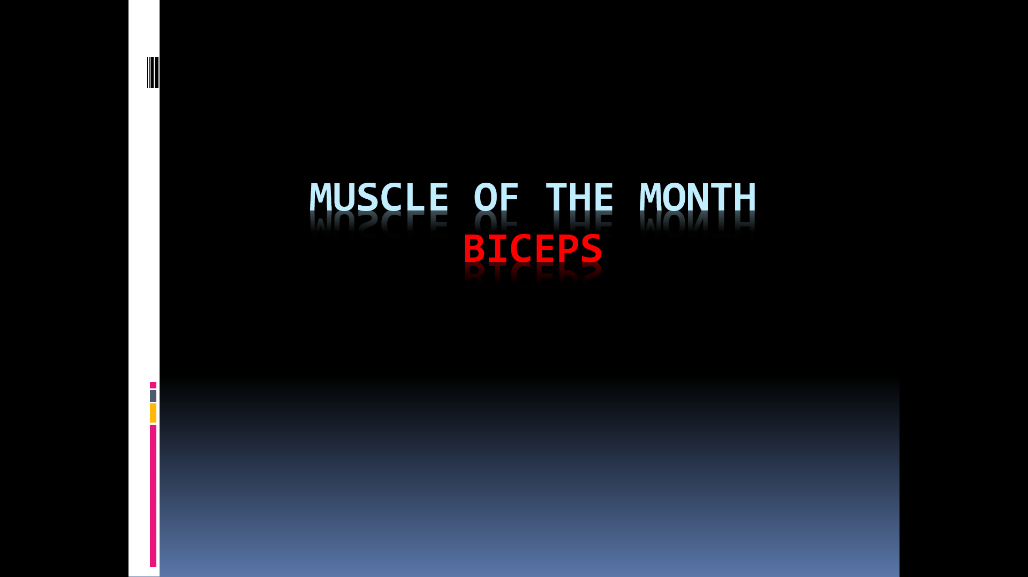
Muscle of the Week

Muscle of the Week

Function of the Biceps
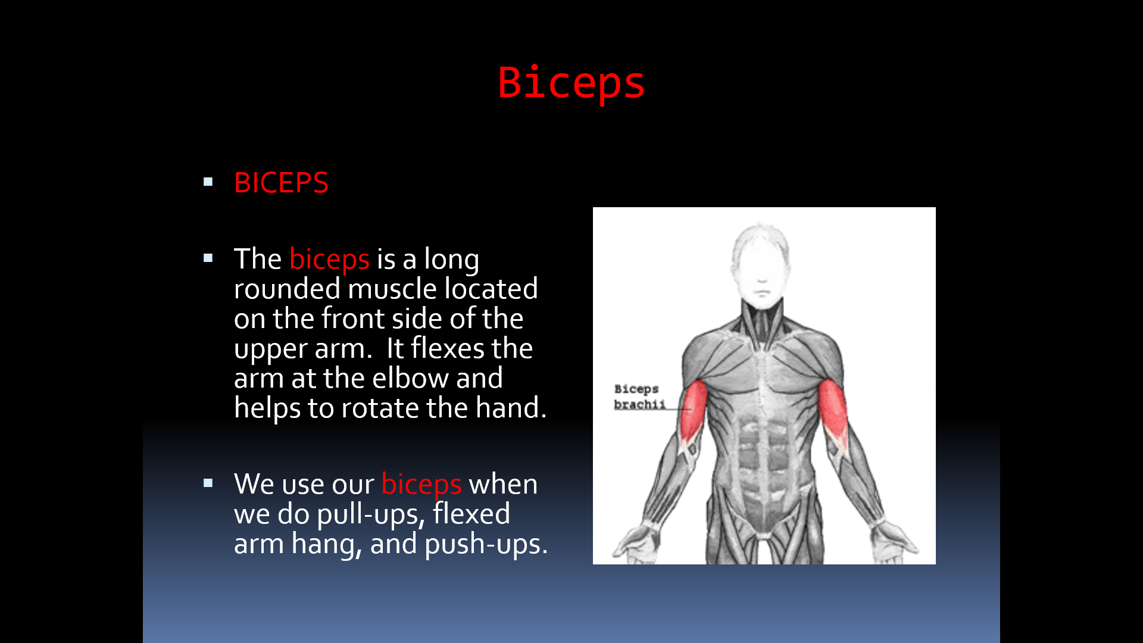

How do we use these muscles in PE?
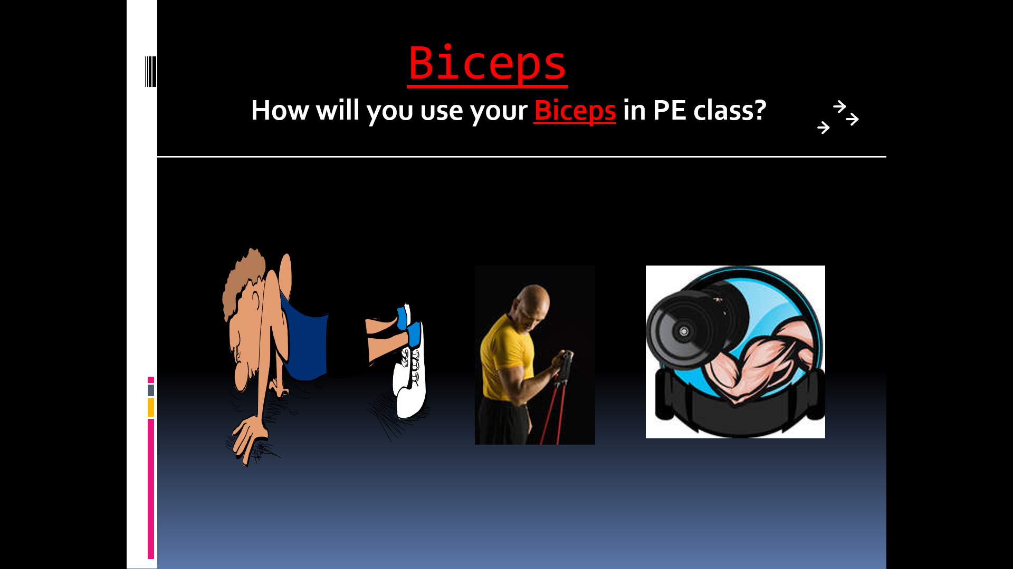
Fitness Tests-we use the Biceps in PE CLASS – Flexed Arm Hang and Pull-up Test
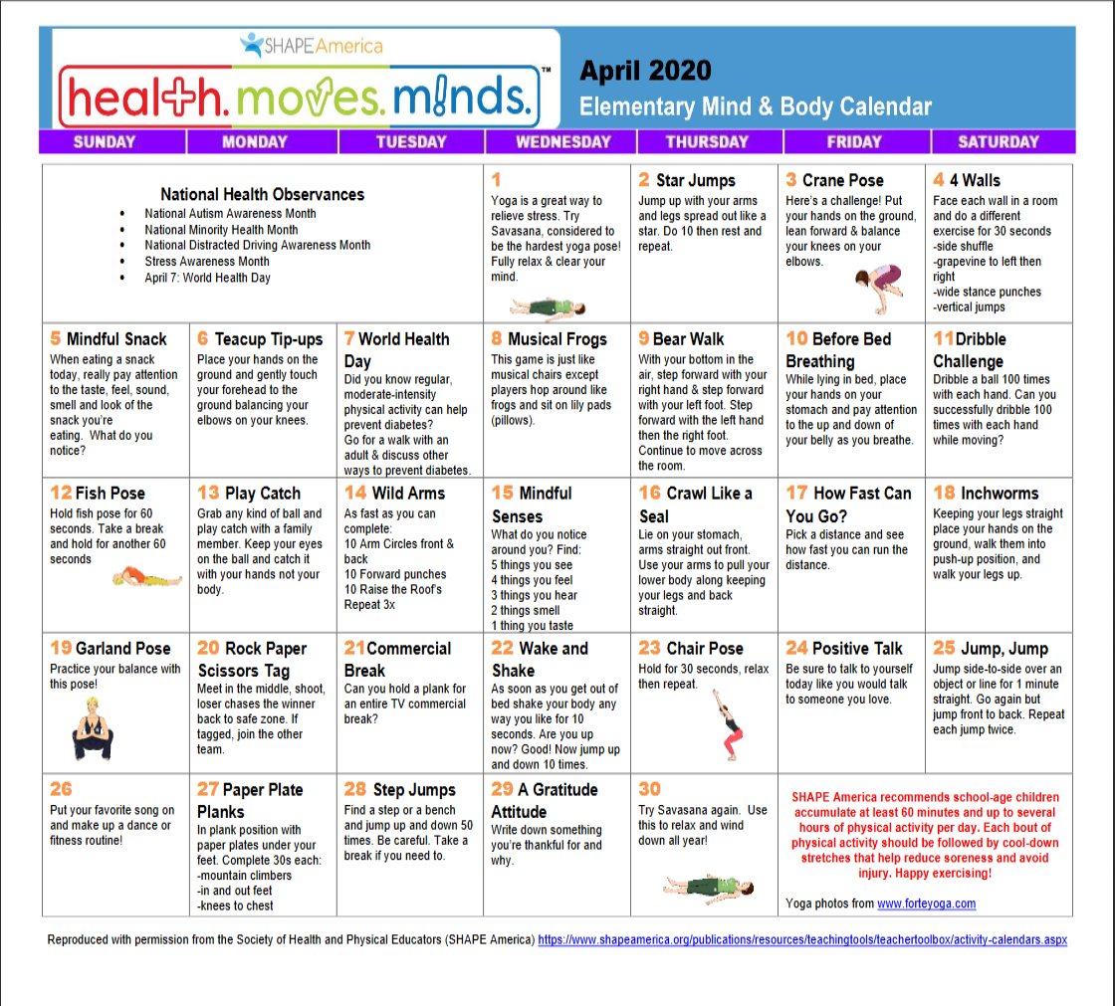

PULL-UPS

(number completed)
AGE | BOYS  ~  FITNESS | BOYS  ~  TITAN | GIRLS  ~  FITNESS | GIRLS  ~  TITAN
6 | 1 | 2 | 1 | 2
7 | 1 | 4 | 1 | 2
8 | 1 | 5 | 1 | 2
9 | 2 | 5 | 1 | 2
10 | 2 | 6 | 1 | 3

FLEXED-ARM HANG

(seconds)
AGE | BOYS  ~  FITNESS | BOYS  ~  TITAN | GIRLS  ~  FITNESS | GIRLS  ~  TITAN
6 | 6 |  | 5
7 | 8 |  | 6
8 | 10 |  | 8
9 | 10 |  | 8
10 | 12 |  | 8

